**Eye Disease Detection Using Deep Learning**

**Introduction**

Eye diseases are a significant global health concern, with conditions such as **cataracts**, **diabetic retinopathy (DR)**, and **glaucoma** leading to vision impairment or blindness if not diagnosed and treated early. Traditional diagnostic methods rely on manual examination by ophthalmologists, which can be time-consuming, expensive, and prone to human error.

**Deep Learning (DL)**, a subset of Artificial Intelligence (AI), has emerged as a transformative tool for automating the detection of eye diseases using medical images. By leveraging **Convolutional Neural Networks (CNNs)** and **Transfer Learning**, we can build highly accurate models to classify eye diseases into four categories: **Normal**, **Cataract**, **Diabetic Retinopathy**, and **Glaucoma**.

This project focuses on developing a deep learning-based system for eye disease detection and integrating it into a user-friendly web application using the **Flask** framework. The system aims to provide a cost-effective, scalable, and efficient solution for early diagnosis of eye diseases.

**Objectives**

By the end of this project, you will:

* Understand the process of preprocessing medical images for deep learning.
* Apply **Transfer Learning** techniques using pre-trained models like **VGG19**, **ResNet50**, **InceptionV3**, and **Xception**.
* Build and train a deep learning model to classify eye diseases into four categories.
* Evaluate the model's performance using metrics such as accuracy, loss, and confusion matrices.
* Develop a web application using **Flask** to deploy the model for real-time predictions.
* Gain insights into the challenges and future scope of deep learning in medical image analysis.

**Project Flow**

The project follows a structured workflow to ensure systematic development and deployment:

1. **Data Collection**: Gather and organize eye disease images into categories.
2. **Data Preprocessing**: Augment and normalize images to prepare them for model training.
3. **Model Building**: Use transfer learning to train a deep learning model on the preprocessed dataset.
4. **Model Evaluation**: Test the model on unseen data to measure its accuracy and generalization ability.
5. **Application Building**: Integrate the trained model into a Flask web application for real-time predictions.
6. **Deployment**: Run the application and allow users to upload images for disease classification.

**Project Structure**

The project is organized into the following folders and files:

* **Dataset**: Contains training and testing images categorized into four classes: Normal, Cataract, Diabetic Retinopathy, and Glaucoma.
* **Training**: Includes the model training notebook and the saved model file.
* **templates**: Contains the HTML file for the web interface.
* **static**: Includes CSS files for styling the web interface.
* **app.py**: The Flask application script for handling user requests and predictions.

Create a Project folder which contains files as shown below

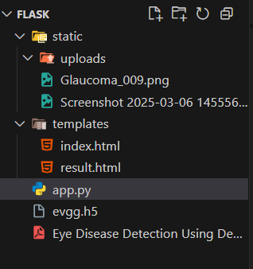

**5. Technical Architecture**

The technical architecture of the project consists of the following components:

1. **Frontend**: HTML and CSS for the user interface, allowing users to upload images and view predictions.
2. **Backend**: Flask framework for handling user requests, processing images, and serving predictions.
3. **Deep Learning Model**: Pre-trained CNN models (e.g., VGG19, ResNet50) for feature extraction and classification.
4. **Database**: Local storage for training and testing datasets.

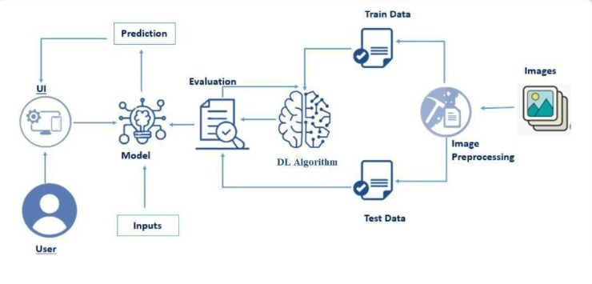

**6. Data Collection**

* **Dataset Source**: The dataset is collected from publicly available sources like **Kaggle** and organized into four categories: **Normal**, **Cataract**, **Diabetic Retinopathy**, and **Glaucoma**.
* **Dataset Link**: [Eye Diseases Classification Dataset](https://www.kaggle.com/datasets/gunavenkatdoddi/eye-diseases-classification)
* **Dataset Structure**:
  + **Training Data**: 3,372 images.
  + **Testing Data**: 845 images.

Dataset folder contains two folders train and test ,which are used to train and test the model.

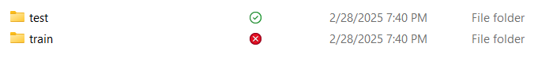

Both train and test contains eye diseases of four categories Normal, Cataract, Diabetic Retinopathy, and Glaucoma.

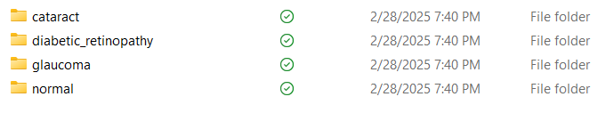

**Data Preprocessing**

* **Image Augmentation**: Techniques like rotation, scaling, flipping, and brightness adjustment are applied to increase dataset diversity and improve model generalization.
* **Normalization**: Pixel values are scaled to the range [0, 1] by dividing by 255 to ensure consistent input for the model.
* **Resizing**: Images are resized to 224x224 pixels to match the input size of pre-trained models like VGG19.

**Model Building**

**Transfer Learning**

* **Pre-trained Models**: VGG19, ResNet50, InceptionV3, and Xception are used as feature extractors. These models are pre-trained on the ImageNet dataset and fine-tuned for the eye disease classification task.
* **Model Architecture**:
  + The base model (e.g., VGG19) is used with frozen layers to extract features from the input images.
  + Additional dense layers are added for classification, followed by a softmax activation layer to output probabilities for the four classes.

**Training**

* The model is trained for 50 epochs using the training dataset.
* Model checkpoints are saved to retain the best-performing model based on validation accuracy.
* The model is evaluated on the testing dataset to measure its performance.
* Metrics such as accuracy, loss, and confusion matrices are used to assess the model's effectiveness.

When You Run train_model.py Loads the **dataset** from Dataset/train/ and Dataset/test/. **After completion** a trained model evgg.h5 is stored in the project directory.

**train_model**

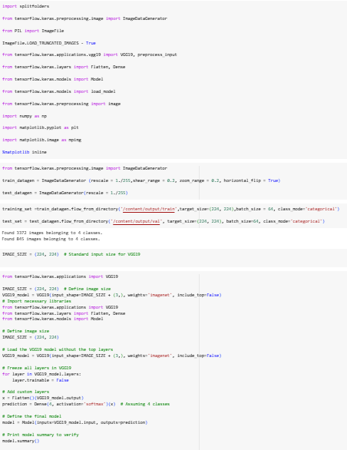

**Application Building**

**Flask Web Application:**

**Backend**

Flask framework for handling image uploads, processing them using the trained model, and displaying the results.

The app.py file is the core backend of the application, responsible for running the **Flask web server**. It loads the **trained deep learning model (evgg.h5)**, processes incoming requests, and serves HTML templates to users. When a user uploads an eye image, app.py preprocesses it and passes it through the deep learning model to predict the disease. The output is then displayed on the web page. This file also manages routing for different pages such as home, image upload, and the about section.

**app.py**

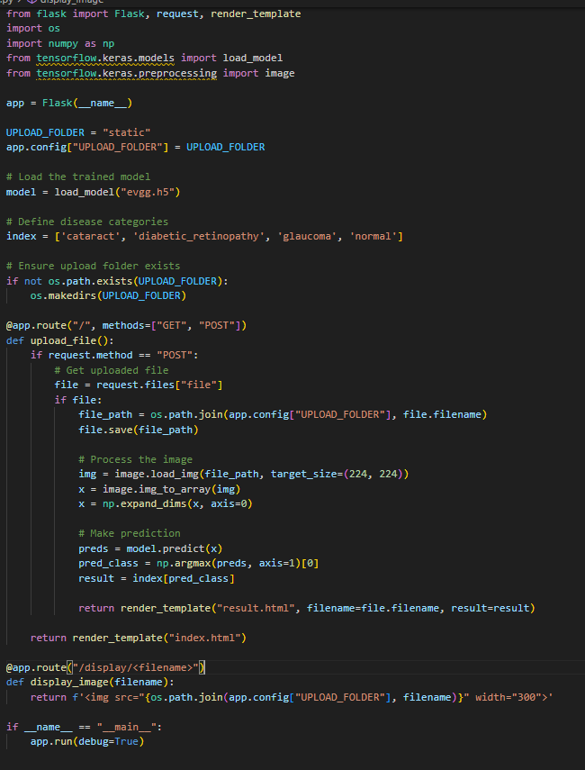

**Frontend**

A simple and intuitive user interface built using HTML and CSS, allowing users to upload images and view predictions.

The web interface includes a file upload feature and a display area to show the uploaded image and the predicted disease class.

The /templates/ folder contains all the HTML files that structure the web interface of the application. These HTML files define the layout and user interaction:

**index.html** serves as the homepage. It introduces the project, provides navigation links, and allows users to proceed to the image upload page.

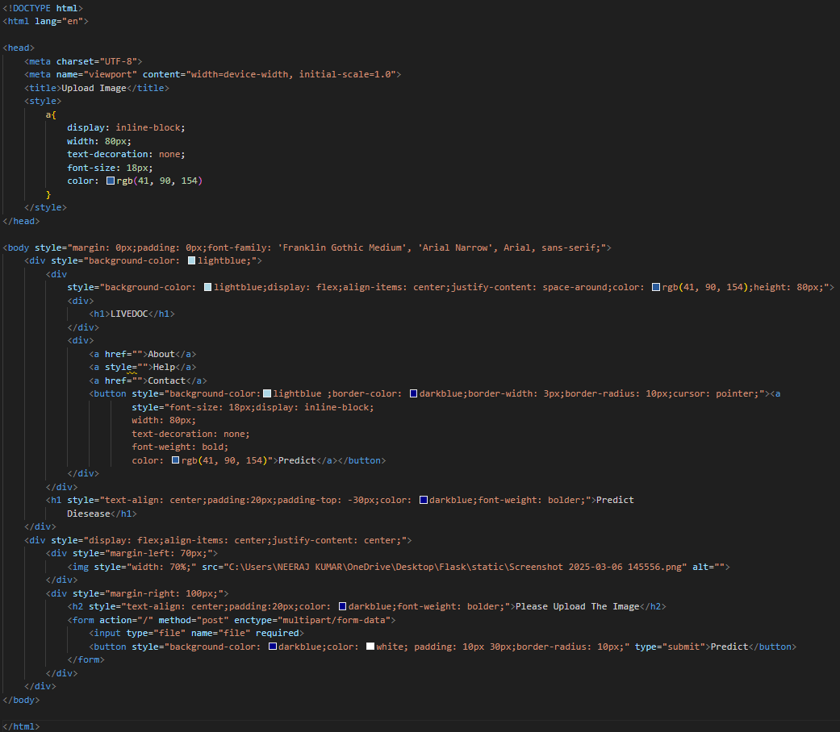

**output.html** displays the prediction results from the model after analyzing the uploaded image, showing whether the eye is normal or affected by cataract, diabetic retinopathy, or glaucoma.

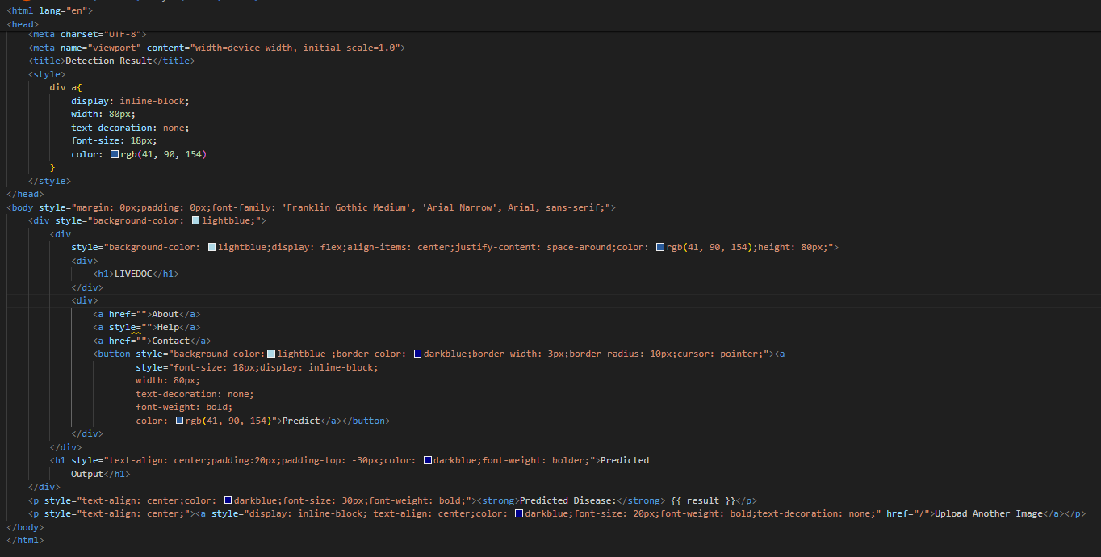

**Static/ - Styling, Images, and Uploaded Files**

The /static/ folder contains all **static files** used in the application, such as CSS styles, images, and uploaded files.

* styles.css is responsible for designing and improving the appearance of the website. It defines the layout, color schemes, button styles, and overall user interface aesthetics.

**Uploads/**

/uploads/ is a subfolder where user-uploaded images are temporarily stored before being processed by the deep learning model.

* /images/ contains preloaded images used for the website’s design, such as background images, icons, or example eye disease images. These files enhance the UI, making the web application visually appealing and easy to use.

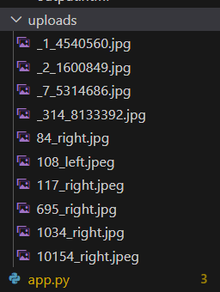

**Running the Code**

The execution of the project begins with training the deep learning model and then deploying it via a Flask web application. The process starts by running the train_model.py script, which loads the dataset, preprocesses the images, and trains a convolutional neural network using transfer learning techniques such as VGG19. Once training is completed, the model is saved as evgg.h5, which serves as the core of the prediction system.

After the model is trained and saved, app.py is executed to launch the Flask web server. The Flask application initializes by loading evgg.h5, setting up routes, and rendering HTML templates. When a user accesses the web application through http://127.0.0.1:5000/, they are directed to the homepage, index.html.

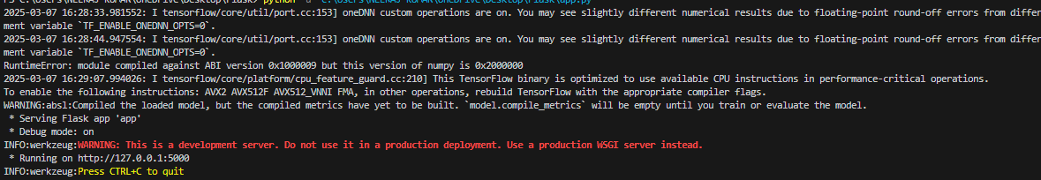

From there, users can navigate to the image upload page, index.html, where they can select an eye image for disease detection. Once an image is uploaded, it is temporarily stored in the /static/uploads/ folder and then passed to the deep learning model for analysis.The model processes the image, predicts the category (Normal, Cataract, Diabetic Retinopathy, or Glaucoma), and sends the result to output.html, where the prediction is displayed. Users can then choose to upload another image or navigate to the about.html page to learn more about the project. The entire process ensures seamless interaction between the backend and frontend components, making it an efficient and user-friendly system for detecting eye diseases.

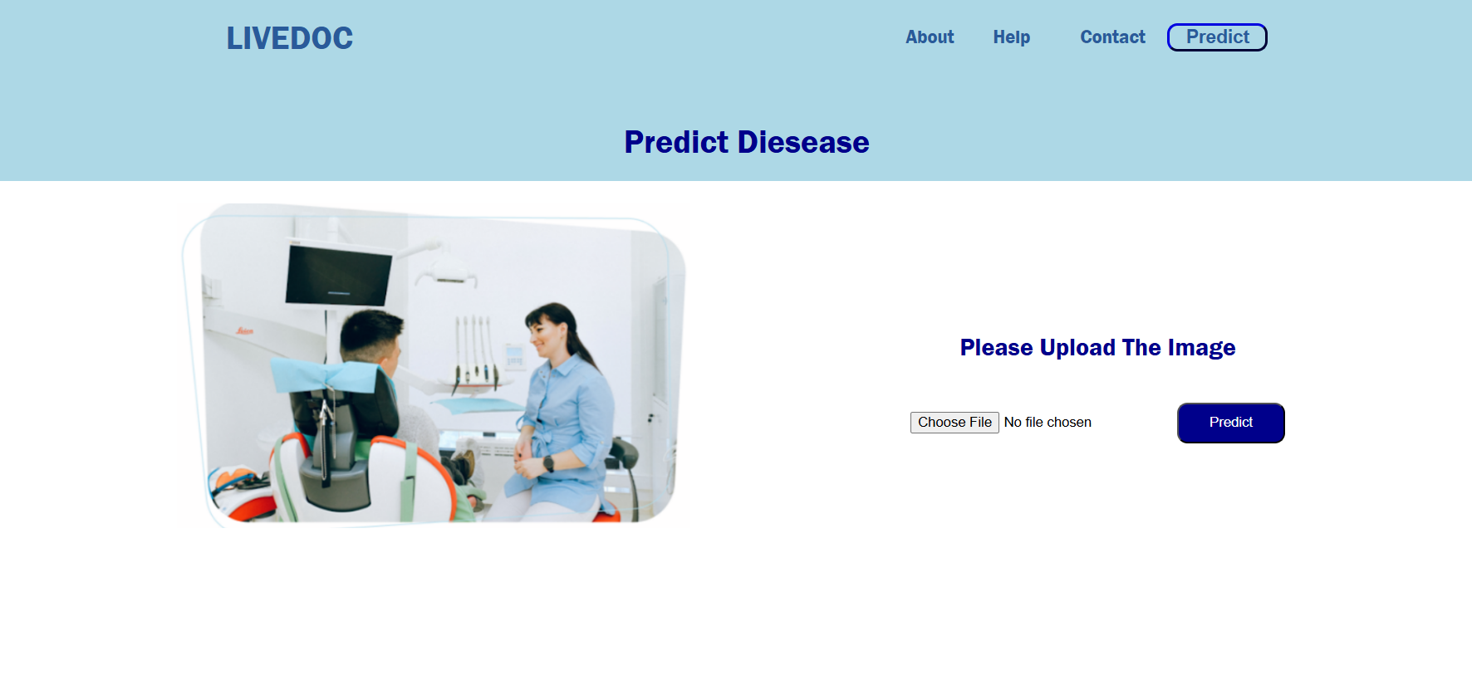

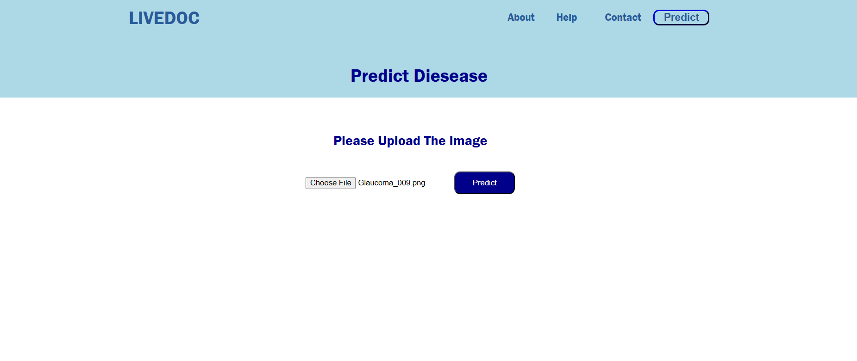

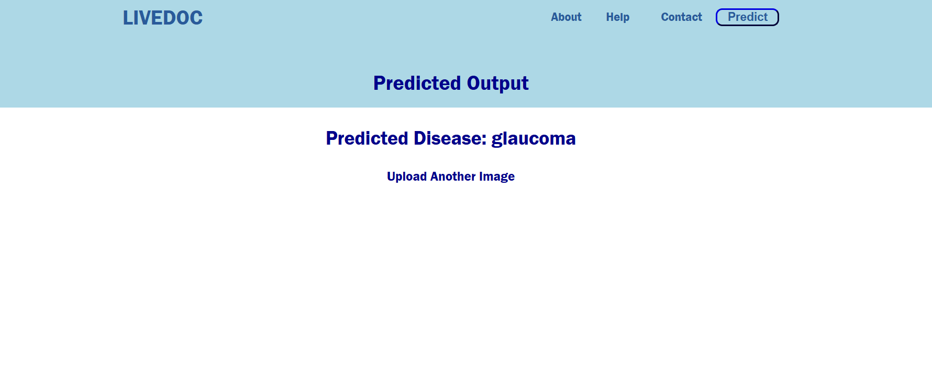

**Conclusion**

This project demonstrates the effectiveness of deep learning in detecting eye diseases using medical images. By leveraging transfer learning and Flask, we have built a scalable and user-friendly system for automated eye disease classification. The system can assist healthcare professionals in diagnosing eye diseases more efficiently and accurately.

Future work can focus on:

* Improving model accuracy by using larger and more diverse datasets.
* Expanding the system to detect additional eye diseases.
* Deploying the application on cloud platforms for wider accessibility.
* Incorporating explainable AI techniques to provide insights into the model's predictions.

This project highlights the potential of deep learning in revolutionizing healthcare and improving patient outcomes.